- \Operation\Inserting\Preinsertion
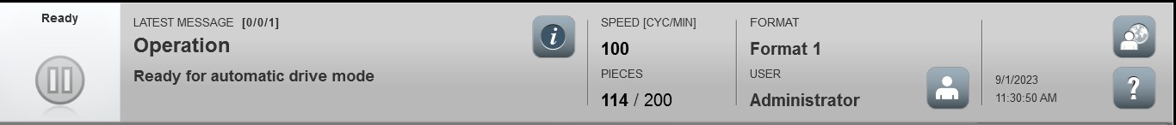
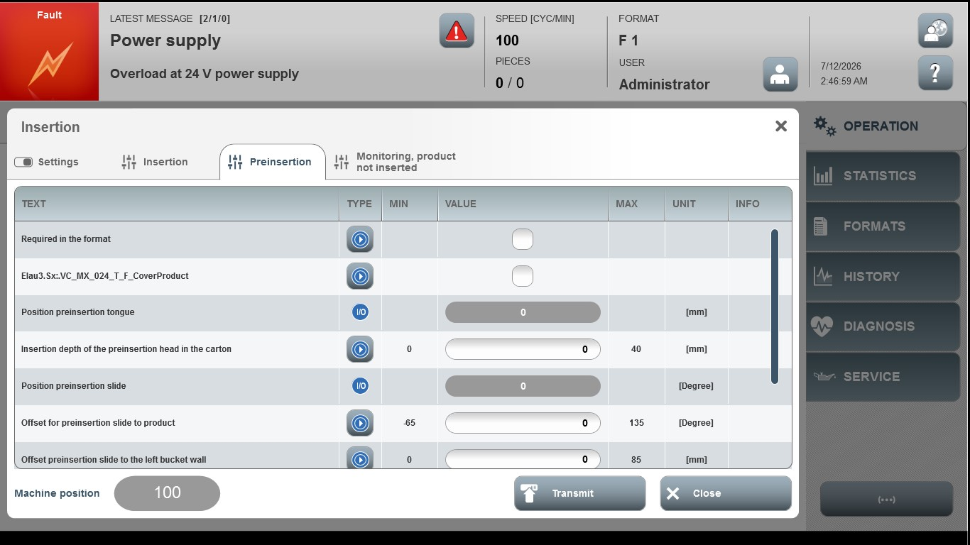

Acceptance criterion | Limits | Pass / Fail: Dev-No. | Date | Initials
Screen matches screenshot | N / A
Product cover by the  preinsertion head before the carton | -50 … 0
Insertion depth of the  preinsertion head in the carton | -10 … 40
Preinsertion movements not precisely reached | 0 … 30
Offset preinsertion slide to the left bucket wall | 0 … 85
Offset slide for adjusting preinsertion to insertion for different product lengths | -65 … 150

